1.1 Sequence Diagram for Add Customer
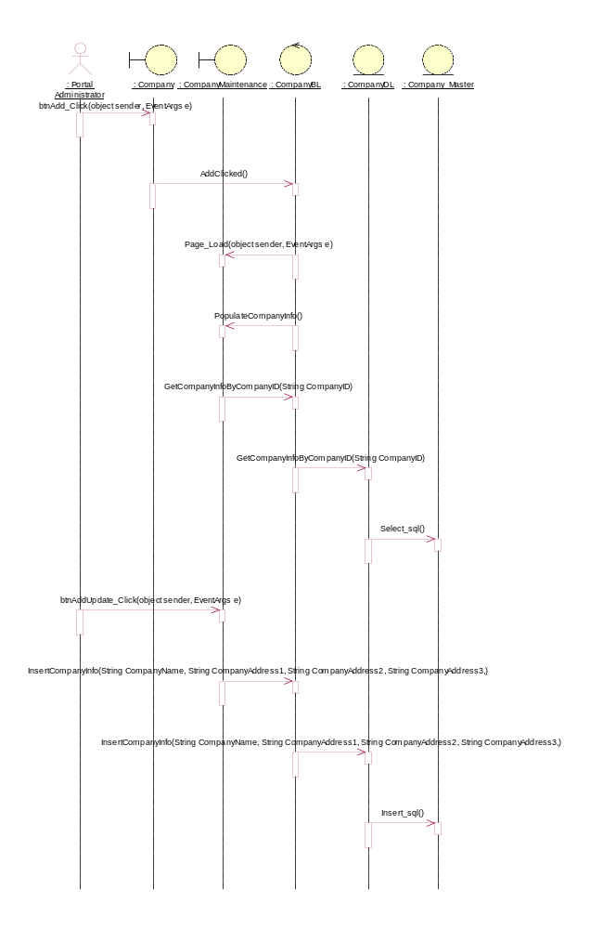
1.2 Sequence Diagram for Delete Customer
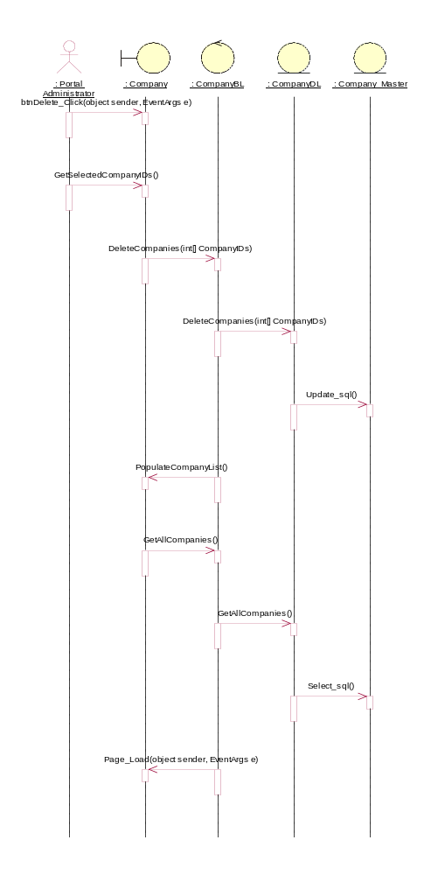

1.3 Sequence Diagram for Update Customer
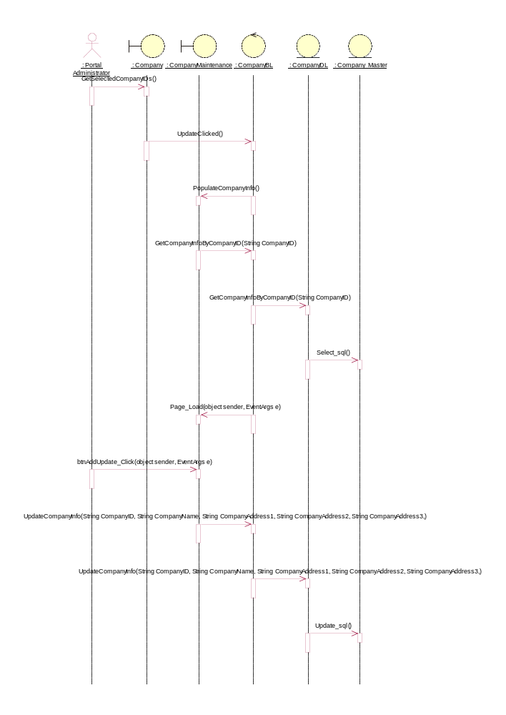

2.1 Sequence Diagram for Add Dap
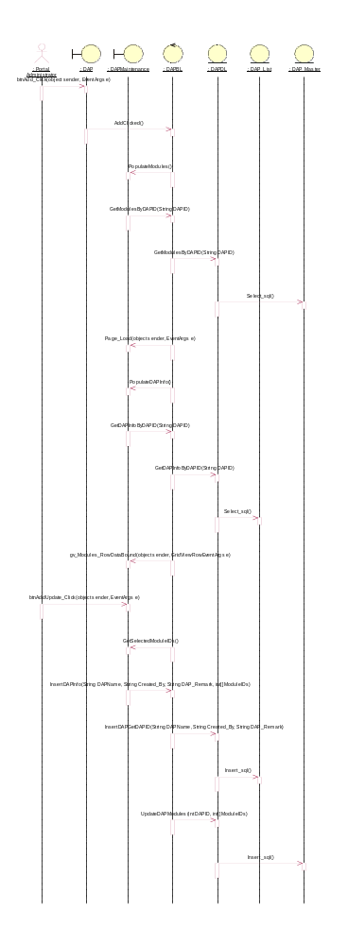
2.2 Sequence Diagram for Delete Dap
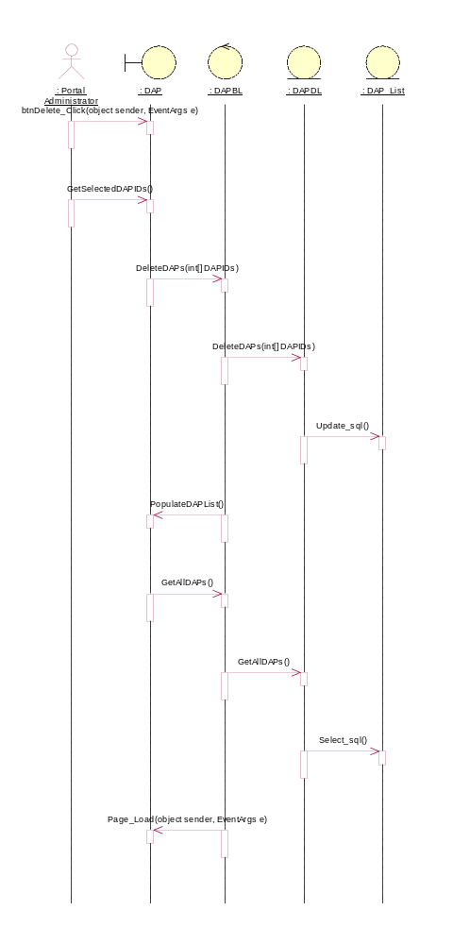
2.3 Sequence Diagram for Update Dap
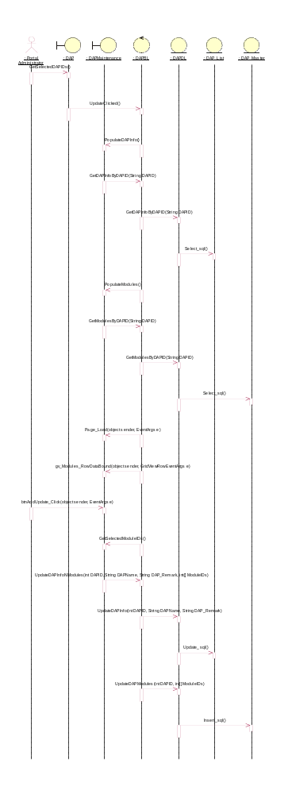
3.1 Sequence Diagram for Add Fap
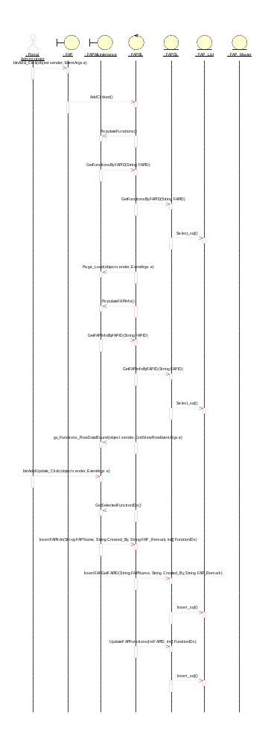
3.2 Sequence Diagram for Delete Fap
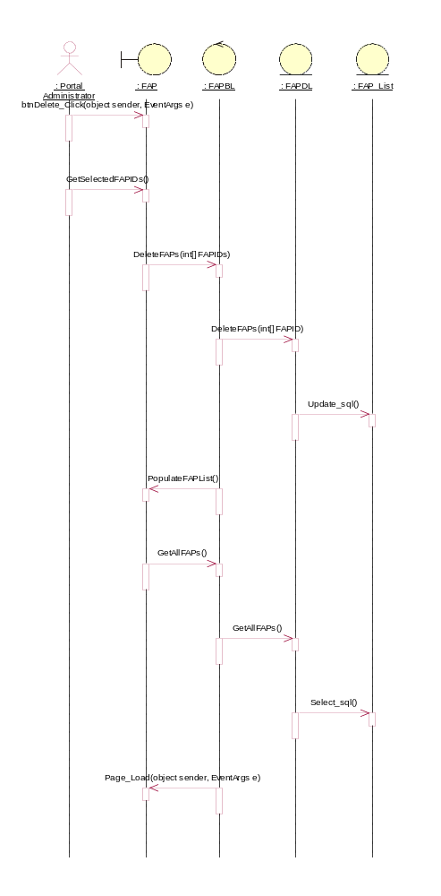
3.3 Sequence Diagram for Update Fap
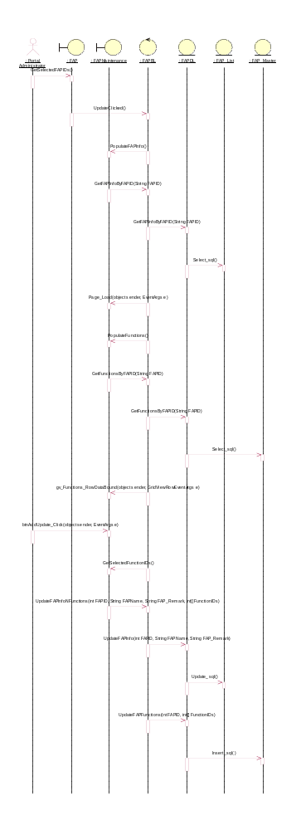
4.1 Sequence Diagram for AddRole
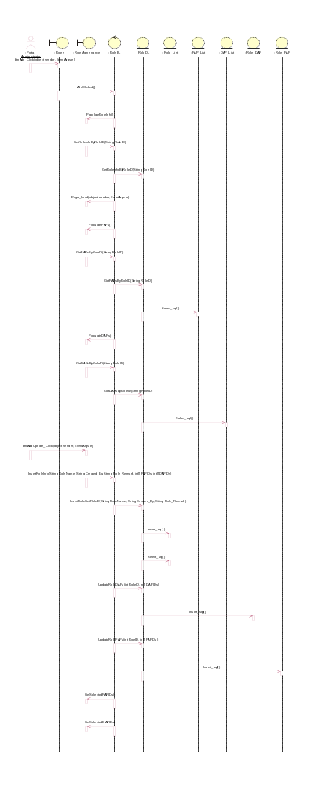
4.2 Sequence Diagram for Delete Role
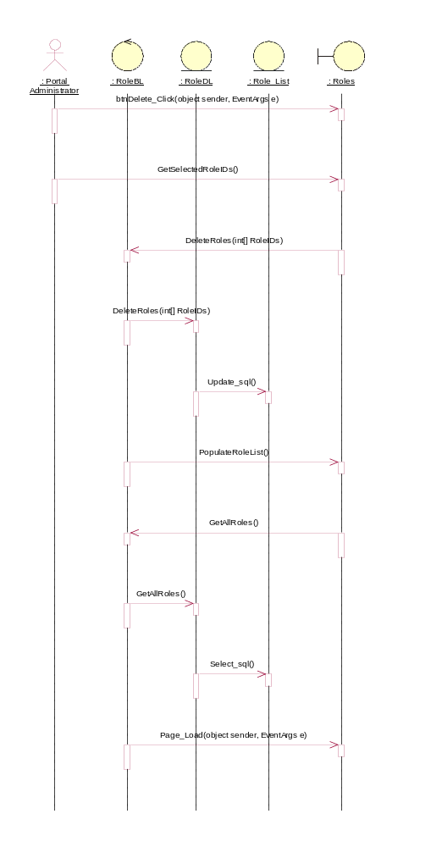
4.3 Sequence Diagram for UpdateRole
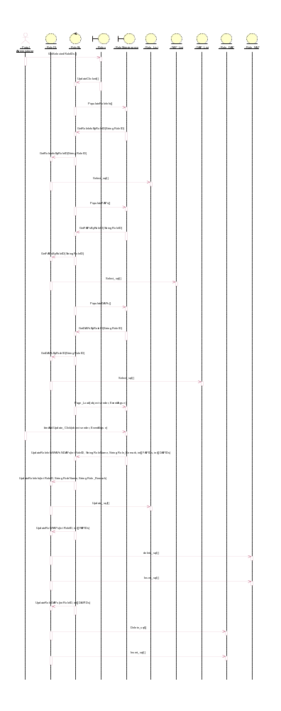
5.1 Sequence Diagram for AddUser
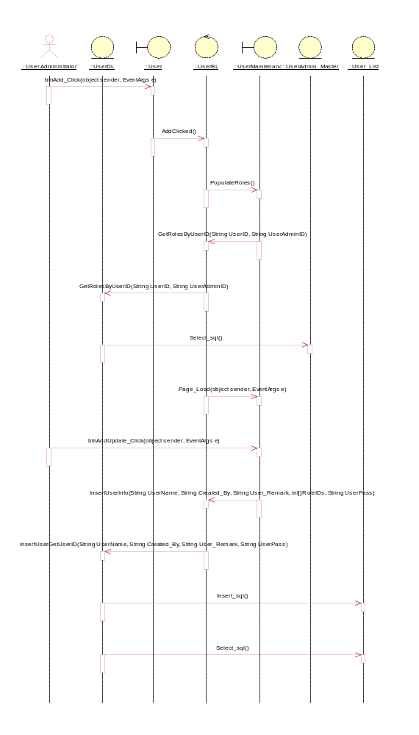
5.2 Sequence Diagram for DeleteUser
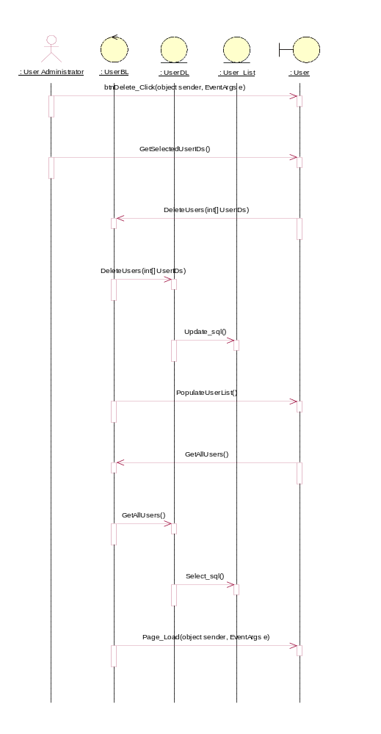
5.3 Sequence Diagram for UpdateUser
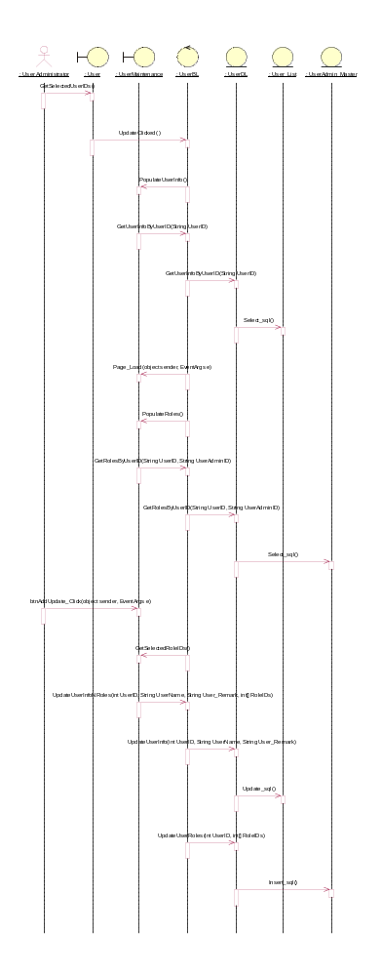
6.1 Sequence Diagram for AddUserAdministrator
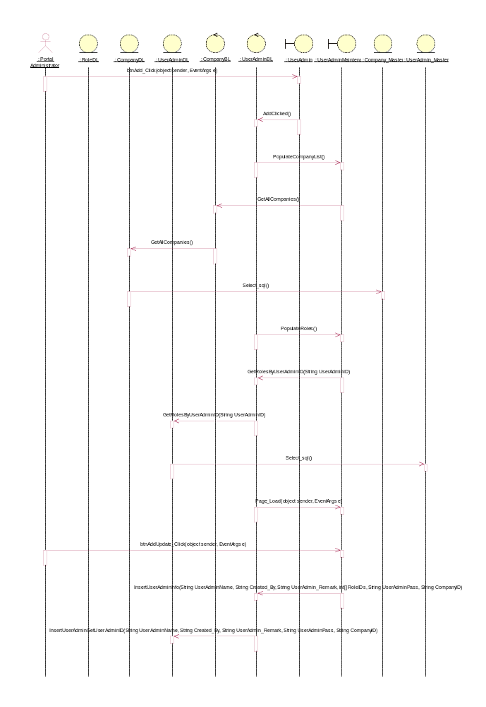
6.2 Sequence Diagram for DeleteUserAdministrator
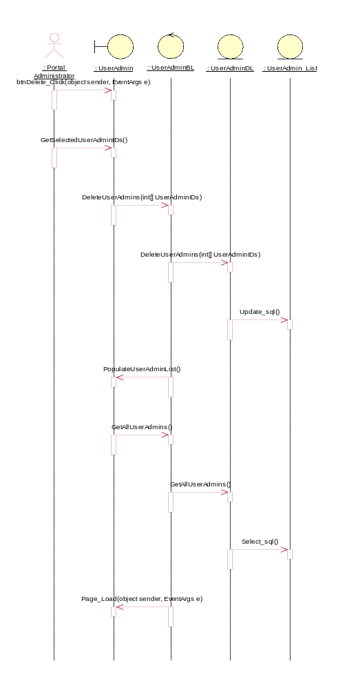
6.3 Sequence Diagram for UpdateUserAdministrator
